

**Airline Reservation System**

**Software Requirement Specification (SRS) Document**

**Sprint 1 Implementation**

**Project Timeline: 07.09.2022 to 15.09.2022**

**INDEX**

1. Introduction

1.1 Purpose -------------------------------------------------- 4

1.2 Intended audience -------------------------------------------------- 4

1.3 Intended use -------------------------------------------------- 4

1.4 Scope -------------------------------------------------- 4

2. Overall description -------------------------------------------------- 5

2.1 Assumptions and dependency -------------------------------------------------- 5

3. System feature and requirements -------------------------------------------------- 5

3.1 Functionality -------------------------------------------------- 5

3.1.1 Customer Structure —----------------------------------------------- 5

3.1.2 Read Customer function -------------------------------------------------- 5

3.1.3 Flight Structure -------------------------------------------------- 5

3.1.4 Read Flight -------------------------------------------------- 5

3.1.5 Allocate Tickets -------------------------------------------------- 6

3.1.6 Display Report -------------------------------------------------- 6

3.1.7 Display Invlaid -------------------------------------------------- 6

3.1.8 Display Unavailable -------------------------------------------------- 6

3.2 System requirement -------------------------------------------------- 6

3.2.1 Tools to be used -------------------------------------------------- 6

3.3 System feature ------------------------------------------------ 6

4. Data Flow Diagram

4.1 DFD level 0 ------------------------------------------------ 8

4.2 DFD level 1 ------------------------------------------------ 9

### **1.** **Introduction: -**

The introduction of the software requirement specification provides an overview of the entire software. The entire SRS with overview description purpose, scope, tools used and basic description. The aim of this document is to gather, analyze and give an in-depth insight into the complete Airline Reservation System application by defining the problem statement in detail. The detailed requirements of the Airline Reservation System application is provided in this document.

**1.1** **Purpose**: **-**The purpose of this document is to show the requirements for the Airline Reservation System application, in which Application to be developed for booking tickets for customers on any available flights.

**1.2** **Intended Audience: -**This document is intended to be read by, Client.

**1.3** **Intended Use: -**

* Development Team
* Maintenance Team
* Clients

Since this a general-Purpose Software any one can access it.

**1.4** **Scope: -**This project aims to create the development of an Airline Reservation System application. Travel agents provide this customer details in multiple text files. Details regarding available flights are available in the “flights.dat” file. After all customer requests are processed, the reservation chart for each flight is displayed and stored in files. Report showing number of allocated seats, empty seats per flight to be displayed and stored in files.

**2. Overall Description: -**

It is an Airline Reservation System application which is used to book tickets for customers on any available flights. Travel agents will provide customer details in multiple text files. Details regarding available flights will be “flights.dat” file. The customer details files will be provided as Command line arguments. Both will contain Id, name, date and no. of seats of flights and customers. At the end, a report showing the number of seats allocated and empty seats are displayed per flight and stored in files . Invalid entries customer details are stored in a separate file. The main purpose is to automate the process of booking flight tickets.

**2.1 Assumptions and Dependency: -**

* System should have Ubuntu Linux installed.
* · System should have either 4GB or more RAM.
* The service is used preferably on a desktop or laptop.

**3.System Features and Requirements: -**

**3.1 Functionality: -**

**3.1.1 AR_03-> Customer_Structure**: We create a linked list structure with ID, name, date & seats fields to store the details.

**3.1.2 AR_03-> Read_Customer**: This function is used to read customer details from the input file. It checks them for valid inputs and passes them to Allocate_Tickets.

**3.1.3 AR_04-> Flight_Structure**: We create a linked list structure with ID, name, date, mutex, total seats & available seats fields to store the flight details.

**3.1.4 AR_04-> Read_Flight**: This function is used to read flight details from the file & store them into the linked list.

**3.1.5 AR_05->** **Allocate_Tickets:** This function allocates tickets to customers by matching the dates with the flights and comparing number of seats and updates the number of seats.

**3.1.6 AR_06-> Display_Report:** This code prints flight ID, flight date, list of customers, No. of seats booked, Number of vacant seats for each flight to a file.

**3.1.7 AR_07-> Display_Invalid:** This code displays invalid booking entries from all input files should be stored to “invalidbooking.txt” file. Invalid entries should be discarded.

**3.1.8 AR_07-> Display_Unavailable_Flights:** This code will display all bookings from input files for which no flight is available to be stored in the “flightsUnavailable.txt” file. Proper error messages should be displayed.

**3.2 System Requirements: -**

### **3.2.1. Tools to be used:**

* Pthread Library
* C Unit Library
* C File Handling
* C Language
* System Programming

### **3.3 System Features: -**

### Supportability:The system is easy to use.

* Design Constraints: The system is built using only C language.
* Usability:The Airline Reservation System application can be used to replace the old means. The system can be used by airlines and travel agents, the system will allocate the seats to the customers and will provide a report on allocated seats, unavailable seats and invalid entries.
* Reliability & Availability**:** The system is available 24/7 that is whenever the user would like to use the system, they can use it up to its functionalities.

### Performance: The system will work on the user’s terminal**.**

**4. DataFlow Diagram:**

**4.1 DFD Level 0 -**

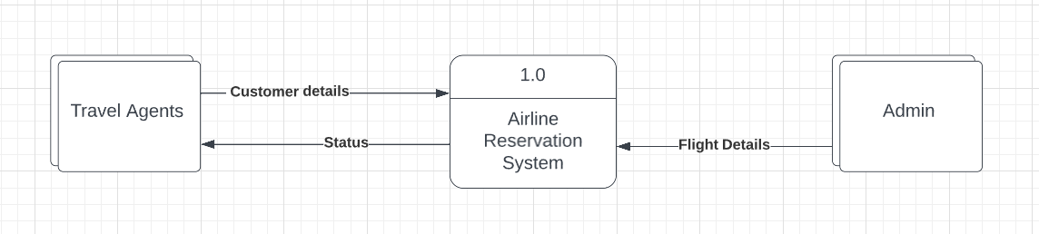

**4.1 DFD Level 1 -**

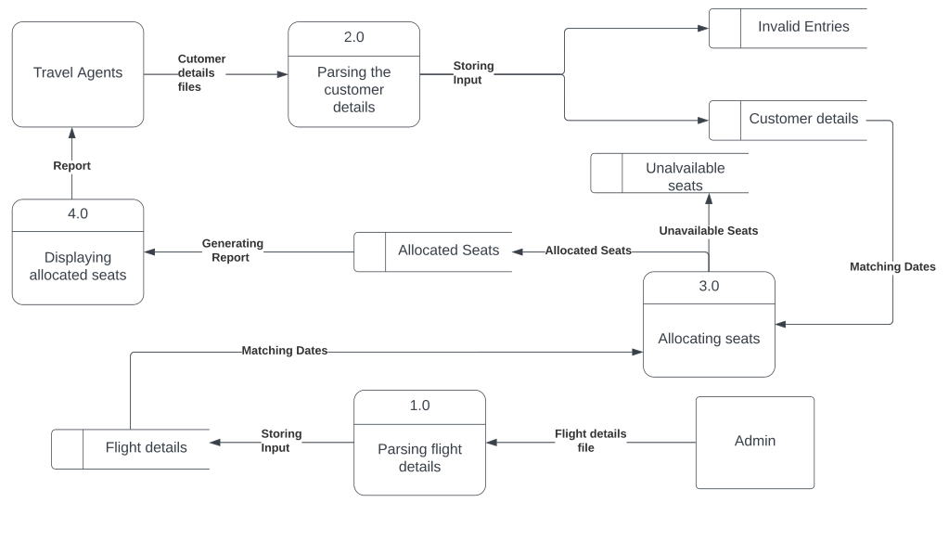

**5. Flow Diagram**

